SIMATS ENGINEERING
ASSESSMENT TOOL 1: Analytical Problem Solving

COURSE NAME: Cloud Computing and COURSE CODE: CSA15
Big Data Analytics

COURSE OUTCOME COVERED
CO2: Analyze virtualization architectures to identify performance and security issues in cloud computing environments. (BL3)

Dave's Taxonomy: Manipulation (Level 2) Total Marks: 50
Question Count: 5
Duration : 60 Minutes

Code of Conduct
I KAVIYA.G(192524281) certify that this submission is my original work and that I have adhered to the guidelines specified for this assessment.
I understand that any violation of academic integrity rules will result in disciplinary action. Signature of the student: kaviya.g

Assessment Tasks Analytical Problem Solving
- Compare Type-1 and Type-2 hypervisors for a cloud datacenter hosting mission-critical applications. Analyze performance, security, and manageability, then justify the better choice.
- A cloud provider must isolate workloads belonging to finance, healthcare, and student portals on the same hardware. Analyze how virtualization architecture supports isolation and identify two major attack surfaces.
- Study the following VM host utilization snapshot and recommend corrective actions: CPU 92%, memory 88%, storage I/O latency 35 ms, average VM boot time 170 s. Explain the likely bottlenecks.
- Analyze how Software Defined Datacenter architecture improves agility compared with a traditional datacenter. Support your answer with compute, storage, and network virtualization considerations.
- A multi-cloud federation project fails due to identity mismatches between providers. Analyze the issue and propose a secure identity and privacy design using federation concepts.
Equivalent Steps in VMware Workstation Pro
  - Library pane showing multiple VMs = multiple instances/regions.
  - VM → Snapshot → Take Snapshot, then Snapshot Manager = backup/versioning demonstration.
  - Edit → Virtual Network Editor to show NAT/Host-only/Bridged networks = hybrid or multi-cloud connectivity.
  - VM → Manage → Clone = replica/auto-scaling demonstration.

Tip: Paste each screenshot directly under the relevant question in this document (Insert → Picture in Word) before final submission, with a one-line caption explaining what it demonstrates.

Analytical Problem Solving Rubric

Criteria | Weightage | Level 4 -  Exemplary | Level 3 –  Proficient | Level 2 -  Developing | Level 1 -  Beginning
Problem  Interpretation | 20% | Interprets all technical requirements accurately | Interprets most requirements correctly | Partial interpretation | Misinterprets the problem
Analytical Reasoning | 25% | Strong reasoning with clear cause-effect analysis | Good reasoning with minor gaps | Basic analysis only | Weak or no analysis
Method Selection | 20% | Chooses highly appropriate virtualization and security concepts | Chooses mostly suitable concepts | Partially suitable concepts | Inappropriate approach
Solution Quality | 20% | Provides feasible and technically sound solution | Reasonable solution with minor issues | Basic solution with limitations | Unclear or invalid solution
Presentation of Analysis | 15% | Well-structured and technically precise | Generally clear | Somewhat unclear | Difficult to follow

Total Marks Awarded:

Set 1 - Question 1: Video Streaming Platform Migration
Scenario: A media company wants to migrate its video streaming platform to the cloud, handling millions of concurrent users with minimal buffering.

1. Scenario Understanding and Key Issues
Requirement | Issue if ignored | Cloud answer
Millions of concurrent users | Server overload, outages | Horizontal scaling and load balancing
Minimal buffering | High latency, poor experience | CDN edge caching and adaptive bitrate streaming
Large video files | High storage and bandwidth cost | Object storage with tiering and compression
Traffic spikes (new releases) | Over-provisioning cost | Auto-scaling with Spot and Reserved mix

2. Cloud Architecture Design (Scalability and Caching)
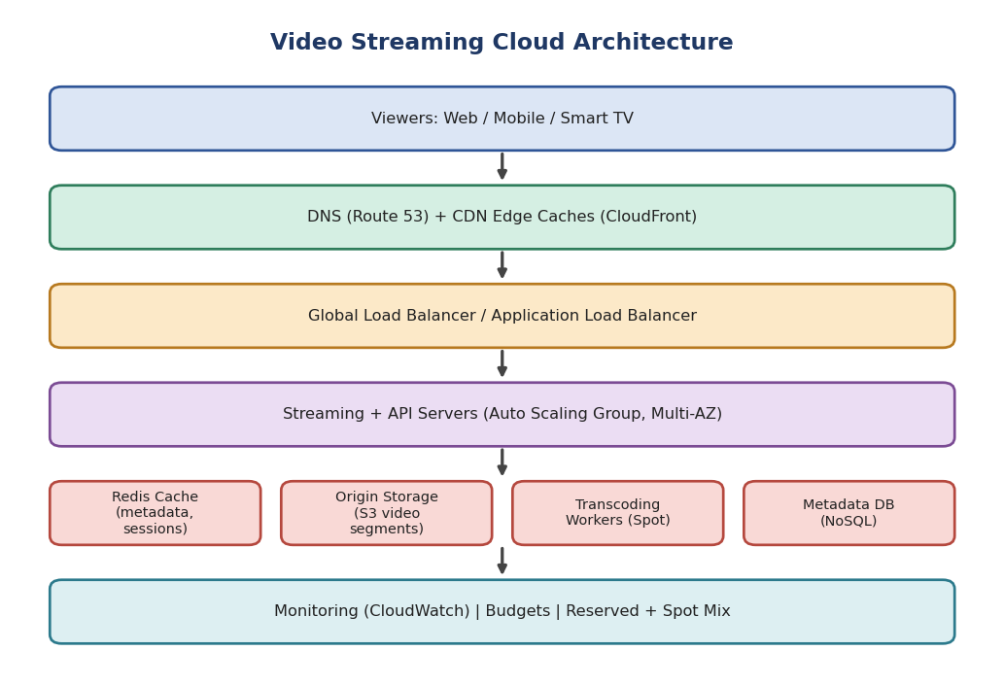
Figure 1: Video streaming architecture with CDN, load balancer and auto scaling
Layer | Component | Purpose / Justification
Edge | CDN (CloudFront / Akamai) with edge caches | Serves popular video segments near the user, reducing latency and origin load by 80-90%
Traffic | DNS (Route 53) + Application Load Balancer | Routes users to the nearest healthy region and distributes requests
Compute | Stateless streaming and API servers in an Auto Scaling Group across multiple AZs | Scale out on demand; failure of one AZ does not stop service
Cache | Redis / ElastiCache | Caches metadata, sessions, recommendations to avoid database hits
Storage | Object storage (S3) holding HLS/DASH segments | Durable, virtually unlimited and cheap storage
Processing | Transcoding workers (queue-driven, Spot instances) | Creates multiple bitrates (240p-4K) for adaptive streaming
Database | NoSQL (DynamoDB) for users, watch history | Single-digit-ms reads at huge scale

3. Load Balancing and Auto-Scaling for Smooth Streaming
- Load balancing: The load balancer spreads connections using round robin or least-connections, runs health checks every few seconds, and removes unhealthy servers. Global DNS uses latency-based routing to pick the closest region.
- Auto-scaling: Scale-out is triggered by CPU above 60%, network throughput or concurrent-connection count. Scale-in happens when load drops. Scheduled scaling prepares capacity before known events (e.g., a big premiere).
- Smooth playback: Adaptive bitrate streaming (HLS/DASH) changes quality based on bandwidth, so the player rarely stalls. Connection draining prevents interruption during scale-in.
- Caching hierarchy: Browser cache -> CDN edge -> regional (mid-tier) cache -> origin. Only cache misses reach the origin.

4. Cost Optimization Strategies
Strategy | How it saves cost
Reserved / Savings Plans for baseline load | Up to 60-70% cheaper than on-demand for steady usage
Spot instances for transcoding | Up to 90% cheaper; jobs are retry-safe and queue-based
Storage tiering (Standard -> IA -> Glacier) | Old, rarely watched titles move to cheaper tiers
High CDN cache-hit ratio and compression (H.265/AV1) | Cuts origin egress, the largest cost in streaming
Right-sizing and scale-in | Pay only for what is needed; remove idle servers
Budgets, tagging and cost alerts | Detects unexpected spikes early

Conclusion: CDN caching, multi-AZ auto-scaling behind load balancers and a blended pricing model deliver low buffering for millions of users at controlled cost.

Set 1 - Question 2: Containers across Multiple Cloud Providers
Scenario: A fintech startup deploys containers across multiple cloud providers and faces challenges in consistency and deployment management.

1. Scenario Understanding and Issues
Challenge | Cause | Solution
Inconsistent environments | Each provider has different tooling and APIs | Kubernetes as a common abstraction
Manual, error-prone deployments | No standard pipeline | CI/CD with GitOps
Configuration drift | Hand-made changes | Declarative YAML/Helm, version-controlled
Security and compliance (fintech) | Secrets and policies differ per cloud | Central secrets (Vault), policy as code

2. Proposed Solution: Container Orchestration and Multi-Cloud Strategy
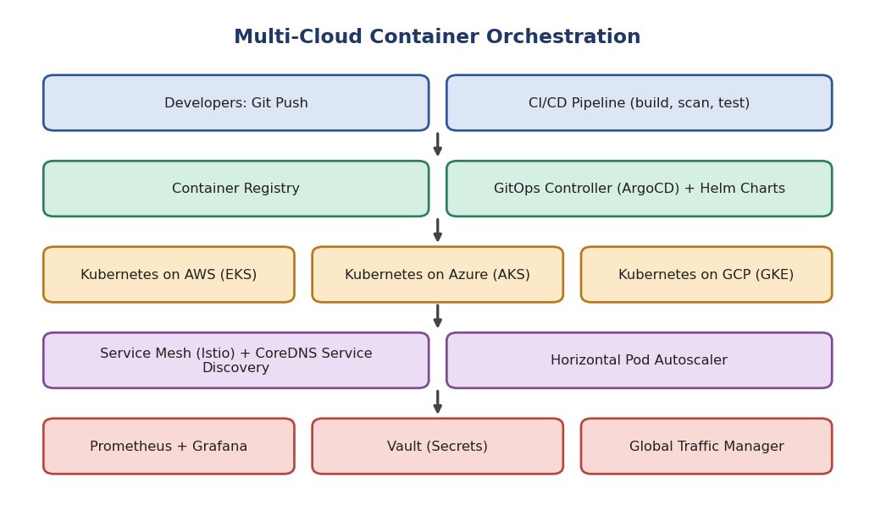
Figure 2: GitOps-driven Kubernetes across AWS, Azure and GCP
- Container orchestration: Kubernetes (EKS, AKS, GKE) schedules, heals, rolls out and scales containers. A single image runs identically on every provider.
- Standardization: Docker images stored in a registry, packaged with Helm charts or Kustomize, so one definition deploys everywhere.
- GitOps (ArgoCD/Flux): Git is the single source of truth. Merge to Git triggers automatic deployment and reverts manual drift.
- Fleet management: Tools such as Rancher, Anthos or Azure Arc manage all clusters from one control plane.
- Traffic: A global traffic manager/DNS routes users to the closest or healthiest cluster.

3. Service Discovery and Scaling
Area | Mechanism | Benefit
Service discovery | Kubernetes Services + CoreDNS give stable DNS names (payments.svc.cluster.local) | Pods can change IP freely without breaking callers
Cross-cluster discovery | Service mesh (Istio / Linkerd) multi-cluster or Consul | Services find each other across clouds with mTLS
Pod scaling | Horizontal Pod Autoscaler on CPU/memory/custom metrics | Handles load spikes automatically
Node scaling | Cluster Autoscaler / Karpenter | Adds or removes VMs as pods need
Event scaling | KEDA scales on queue length | Efficient for async workloads
Safe rollout | Rolling / canary deployments with readiness probes | Zero downtime releases

4. Benefits and Risks of Multi-Cloud
Benefits | Risks
Avoids vendor lock-in and improves negotiating power | Higher operational complexity and skill requirements
Resilience: survives a full provider outage | Inter-cloud data transfer (egress) costs
Choose best service per cloud and meet data residency rules | Inconsistent security models; larger attack surface
Cost optimization by shifting workloads | Latency between clouds; harder debugging and monitoring
Regulatory flexibility (important for fintech) | Risk of lowest-common-denominator design that ignores native features

Mitigation: Use Infrastructure as Code (Terraform), unified observability (Prometheus/Grafana), centralized IAM and policy-as-code (OPA).

Set 1 - Question 3: Backup and Disaster Recovery for E-Learning
Scenario: An e-learning platform suffered data loss due to accidental deletion and needs a robust backup and disaster recovery strategy.

1. Scenario Understanding and Risks
Risk | Impact | Control
Accidental deletion | Lost course content and student records | Versioning, soft delete, MFA delete
Ransomware / malicious deletion | Backups also encrypted or deleted | Immutable backups (Object Lock), separate account
Hardware or AZ failure | Downtime | Multi-AZ and replication
Regional disaster | Total outage | Cross-region replication and DR site
Human error in restore | Prolonged recovery | Documented runbooks and drills

2. Solution Design: Backup, Replication and Versioning
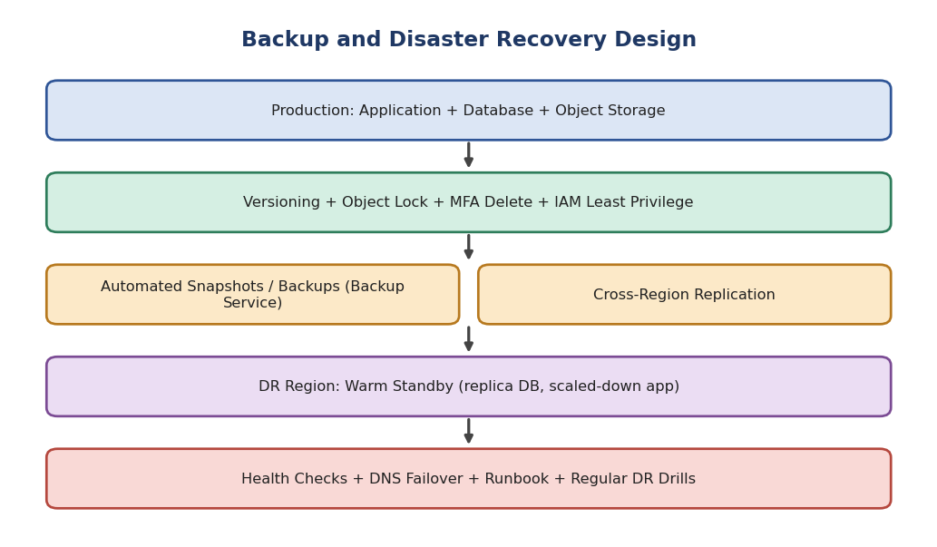
Figure 3: Backup and disaster recovery design
Mechanism | Implementation | Protects against
Versioning | Enable on object storage; keep previous versions for 30-90 days with lifecycle rules | Accidental overwrite/delete (restore previous version)
Cloud-native backup | AWS Backup / Azure Backup: scheduled daily snapshots of DB, volumes, file systems; retention policy | Data corruption, point-in-time recovery
Point-in-time recovery | Database continuous log backup (e.g., RDS PITR) | Recover to any second within retention
Replication | Cross-Region Replication of storage; read replica / global database | Region failure
Immutability | Object Lock (WORM) and backup vault lock; backup stored in a separate account | Ransomware and insider deletion
Access control | Least-privilege IAM, MFA delete, deletion alerts | Accidental or malicious deletion

3. Achieving RTO and RPO
RPO (Recovery Point Objective) is the maximum acceptable data loss measured in time. RTO (Recovery Time Objective) is the maximum acceptable downtime. For an e-learning platform a reasonable target is RPO of 5 minutes or less and RTO of 1 hour or less.
DR Strategy | RPO | RTO | Cost | Technique
Backup and Restore | Hours | Hours | Lowest | Periodic snapshots restored on demand
Pilot Light | Minutes | Tens of minutes to hours | Low | Replicated data, minimal core services running
Warm Standby (chosen) | Seconds to minutes | Minutes | Medium | Scaled-down full copy, continuously replicated
Multi-Site Active/Active | Near zero | Near zero | Highest | Full capacity in two regions

- RPO is achieved by: continuous replication, frequent snapshots (every 5-15 minutes), transaction-log shipping and versioning.
- RTO is achieved by: automation (Infrastructure as Code), pre-provisioned warm standby, DNS failover with health checks, tested runbooks.

4. Steps to Ensure Business Continuity During Failures
- Step 1 - Detect: Health checks and alarms identify the failure automatically.
- Step 2 - Declare and notify: The incident team is alerted via SNS/PagerDuty; stakeholders informed.
- Step 3 - Failover: DNS (Route 53) shifts traffic to the DR region; the standby database is promoted to primary.
- Step 4 - Scale up: Auto-scaling expands the standby application tier to production capacity.
- Step 5 - Restore data if needed: Recover deleted items from versions or point-in-time backup.
- Step 6 - Verify: Run smoke tests on login, course access and quizzes; communicate status to students.
- Step 7 - Failback and review: Return to primary after repair; do a post-incident review and update the plan.
- Ongoing: Test restores quarterly, run DR drills, and keep documentation current.

Set 1 - Question 4: Hybrid Cloud for a Government Agency
Scenario: A government agency adopts a hybrid cloud with sensitive data and compliance-bound applications on-premises and non-sensitive workloads in the cloud.

1. Scenario Understanding and Issues
Issue | Explanation
Data classification | Sensitive data must stay on-premises; public-facing and non-sensitive systems can use the cloud
Secure connectivity | Traffic between environments must not be exposed to the internet
Compliance | Audit, residency and access rules must be enforced equally in both worlds
Identity | Users should have one identity across on-premises and cloud

2. Hybrid Architecture with Secure Communication
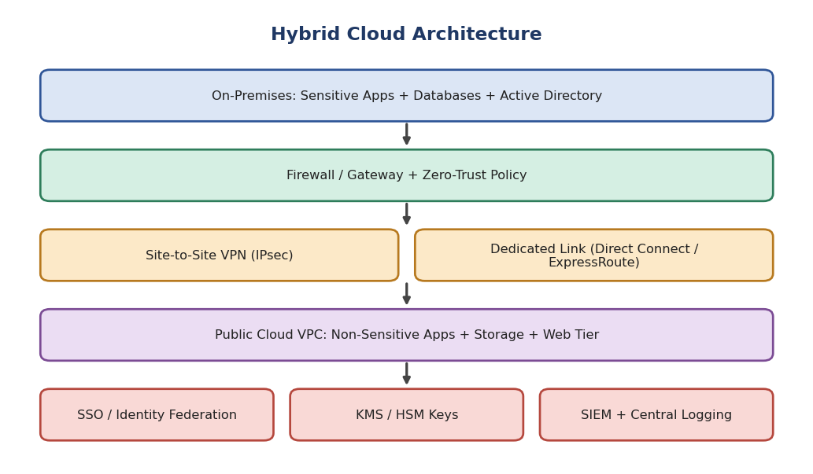
Figure 4: Hybrid cloud architecture
Component | Design Decision | Justification
On-premises | Sensitive databases and legacy apps, private cloud (VMware/OpenStack) and Active Directory | Meets data sovereignty and compliance
Connectivity | Primary: dedicated private link (Direct Connect / ExpressRoute). Backup: IPsec site-to-site VPN | Low latency, private path and failover
Network security | Next-generation firewall, network segmentation (VPC/VNet, subnets), security groups, private endpoints | Limits lateral movement and exposure
Cloud side | Non-sensitive web tier, analytics on anonymised data, backup and burst capacity | Elastic scalability at lower cost
Data exchange | API gateway and tokenisation/anonymisation before data leaves on-premises | Only permitted data moves
Monitoring | Central SIEM collecting logs from both environments | Single view for audit

3. Identity Management and Encryption
Area | Implementation
Federated identity / SSO | Sync on-premises Active Directory with cloud IAM (Azure AD / AWS IAM Identity Center) using SAML/OIDC; one identity for all systems
Multi-factor authentication | Mandatory MFA for all users, stronger (hardware keys) for administrators
RBAC and least privilege | Role-based permissions; just-in-time access for admins; periodic access reviews
Privileged access management | Session recording, vaulted admin credentials
Encryption in transit | TLS 1.2+ for applications; IPsec / MACsec on links
Encryption at rest | AES-256 for databases, disks and storage
Key management | KMS / HSM with customer-managed keys; keys for sensitive data remain on-premises HSM; rotation and separation of duties
Zero-trust | Verify every request by identity, device and context rather than network location

4. Challenges in Managing Hybrid Cloud
Challenge | Mitigation
Complexity of two environments and different tools | Unified management (Azure Arc, Anthos, Terraform)
Consistent security policy and compliance | Policy as code, central SIEM and compliance dashboards
Latency and bandwidth between sites | Dedicated links, data locality, caching
Data synchronisation and integrity | Event-driven replication, clear system of record
Skill gaps and integration of legacy systems | Training, API wrappers, phased modernisation
Cost visibility across environments | FinOps tagging and combined reporting

Set 1 - Question 5: SaaS High Availability and Fault Tolerance
Scenario: A SaaS provider needs its application to keep operating even if one region goes down.

1. Scenario Understanding and Risks
Risk | Effect | Countermeasure
Regional outage | Complete service loss | Active deployment in a second region
Data loss on failover | Customers lose transactions | Synchronous / near-real-time replication
Slow detection | Longer downtime | Health checks and proactive alerts
Split-brain / inconsistent data | Corrupted state | Single-writer or conflict-resolution strategy

2. Multi-Region Deployment Strategy
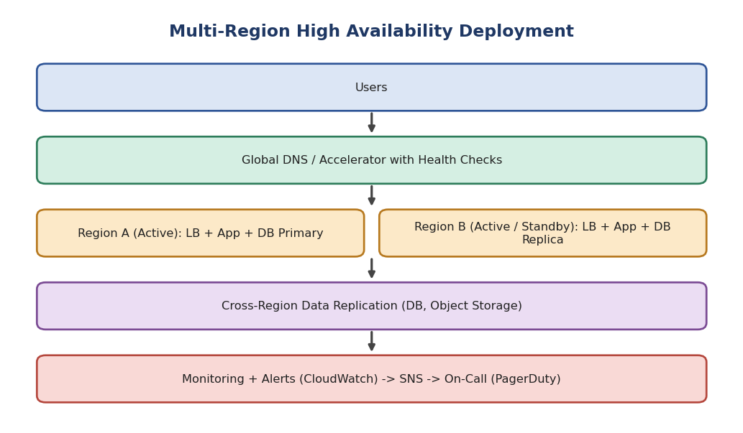
Figure 5: Multi-region active/standby deployment with global routing
Model | Description | Use
Active-Passive | Region B is standby, promoted on failure | Simpler and cheaper; RTO of minutes
Active-Active (recommended for SaaS) | Both regions serve traffic; each can take 100% load | Best availability and lower latency; more complex data handling

- Deploy identical stacks via Infrastructure as Code in at least two regions, each across multiple AZs.
- Use stateless application servers behind a regional load balancer; sessions stored in shared cache or tokens (JWT).
- Use global DNS (latency/failover routing) or a global accelerator to direct users to the nearest healthy region.
- Size each region to handle full load (N+1 capacity) with auto-scaling.

3. Data Replication and Failover Configuration
Layer | Configuration
Relational database | Global database / cross-region read replica with asynchronous replication (RPO in seconds); promote replica on failure. Use synchronous replication within the region across AZs
NoSQL | Multi-region tables (DynamoDB Global Tables / Cosmos DB) with last-writer-wins or custom conflict resolution
Object storage | Cross-region replication with versioning
Cache and queues | Rebuildable caches; replicated queues or idempotent consumers
DNS failover | Health checks every 10 seconds; failover after 2-3 failed checks; low TTL (30-60 s)
Automation | Runbooks / automation scripts for promotion and failback; regular game-day failover tests

4. Monitoring and Alerting for Proactive Detection
Type | What is monitored | Tools
Infrastructure metrics | CPU, memory, disk, network, replication lag | CloudWatch, Azure Monitor, Prometheus
Application metrics (SLIs) | Latency, error rate, throughput, saturation | APM (Datadog, New Relic)
Synthetic monitoring | Simulated user logins from multiple regions | Route 53 health checks, Pingdom
Logs and traces | Errors and request paths across services | ELK, CloudWatch Logs, X-Ray / Jaeger
Alerting | Threshold and anomaly alerts with severity levels, escalation policy | SNS, PagerDuty, Slack, Opsgenie
SLO tracking | Error budgets, uptime target (e.g., 99.99%) | Grafana dashboards

Set 2 - Question 1: Retail Big Data Analytics (Near Real Time)
Scenario: A retailer collects terabytes of transaction data daily and wants near-real-time analysis for recommendations and inventory.

1. Cloud Big Data Architecture (Distributed Storage and Processing)
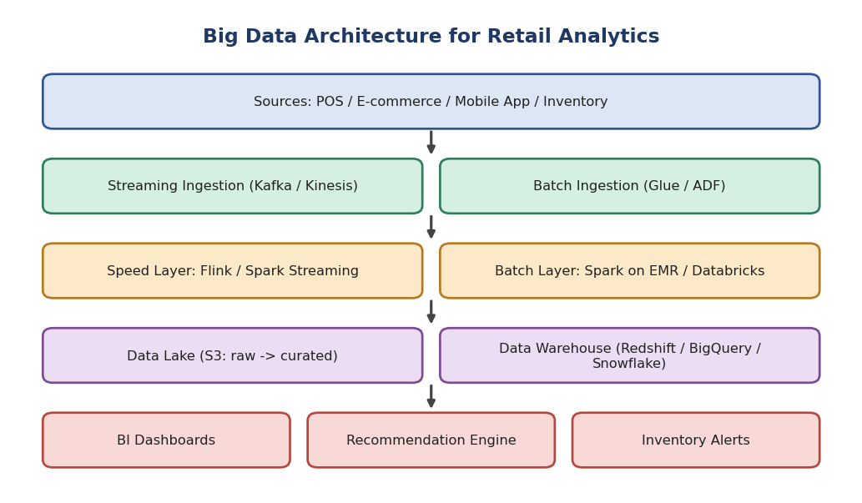
Figure 6: Lambda-style big data architecture for retail
Layer | Technology | Role
Ingestion | Kafka / Kinesis (streams); Glue / Data Factory / Sqoop (batch from store databases) | Collects online and offline transactions
Distributed storage | HDFS or cloud object storage (S3 / ADLS) as data lake | Cheap, scalable, stores raw and processed data
Distributed processing | Apache Spark (EMR / Databricks), Flink | Parallel processing across cluster nodes
Serving | Data warehouse (Redshift / BigQuery / Snowflake), Redis / NoSQL for low-latency lookups | Fast queries and recommendations
Consumption | BI dashboards, recommendation API, inventory alerts | Business value

2. Integrating Batch and Stream Processing
Aspect | Batch Processing | Stream Processing
Data | Full historical data | Continuous events
Latency | Hours | Seconds
Use here | Nightly demand forecasting, customer segmentation, model training | Live recommendations, stock-out alerts, fraud checks
Tools | Spark batch, Hive | Spark Structured Streaming, Flink, Kafka Streams

- Lambda architecture: The same events flow to a speed layer (real-time views) and a batch layer (accurate recomputed views). A serving layer merges both.
- Kappa / unified option: Use one streaming engine (Spark Structured Streaming or Flink) for both, replaying the Kafka log for reprocessing; simpler to maintain.
- Delta Lake / Iceberg tables allow streaming and batch jobs to read and write the same tables with ACID guarantees.

3. Data Lake and Data Warehouse Together (Lakehouse Pattern)
Feature | Data Lake | Data Warehouse
Data type | Raw, structured and unstructured (logs, clicks, JSON) | Cleaned, structured, modelled
Schema | Schema-on-read | Schema-on-write
Users | Data scientists, engineers | Analysts, business users
Cost | Low | Higher but optimized for SQL

Raw data lands in the lake (bronze), is cleansed and enriched (silver), then aggregated into curated tables loaded into the warehouse (gold) for dashboards. The lake keeps full history for machine learning and reprocessing, while the warehouse serves fast, governed BI queries. Modern lakehouse platforms combine both.

4. Scalability and Cost Efficiency
- Scalability: Partition Kafka topics, auto-scale Spark clusters, decouple storage from compute, use serverless query engines.
- Storage cost: Columnar formats (Parquet/ORC) with compression, lifecycle tiering to cold storage, partitioning by date and store.
- Compute cost: Spot instances for batch, auto-terminate idle clusters, reserved capacity for steady streaming jobs.
- Query cost: Materialized views, partition pruning, caching of results.
- Governance: Tagging and budgets for FinOps visibility.

Set 2 - Question 2: Healthcare Cloud Security and Compliance
Scenario: A healthcare organization migrates patient records and imaging to the cloud under strict privacy regulations, with secure multi-location doctor access.

1. Secure Cloud Architecture
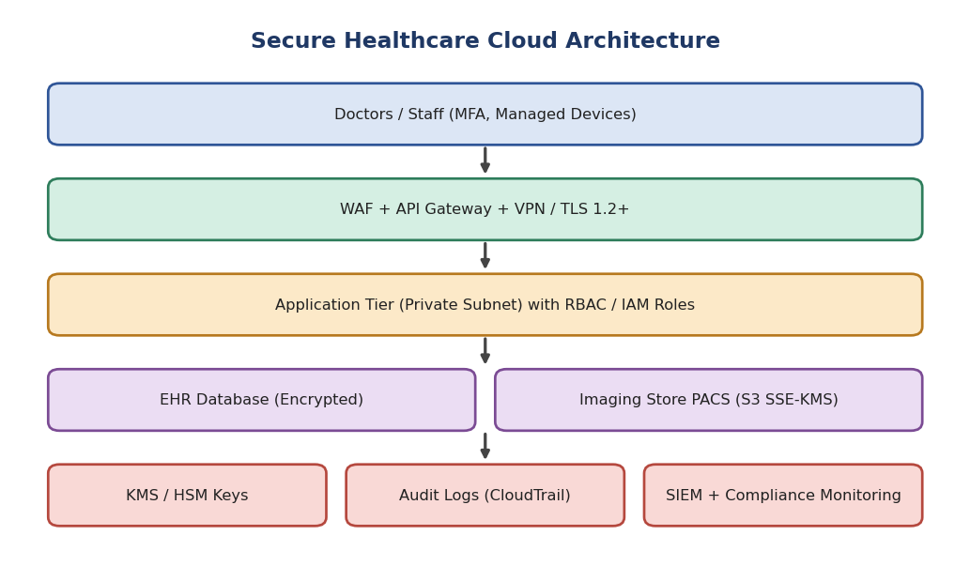
Figure 7: Secure healthcare cloud architecture
Layer | Design | Why
Access | MFA, managed devices, VPN / private access, conditional access | Verifies doctors from any location
Perimeter | WAF, DDoS protection, API gateway, TLS 1.2+ | Blocks attacks and enforces encrypted channels
Network | Private subnets, segmentation by sensitivity, no public database endpoints, private links | Reduces exposure
Application | Role-based EHR app, session timeout, input validation | Controls what each user can see
Data | Encrypted EHR database; medical images (DICOM) in encrypted object storage with lifecycle tiering | Protects PHI at rest
Operations | SIEM, logging, backup, DR | Detects, audits and recovers

2. Encryption, IAM and Key Management
Control | Implementation
Encryption at rest | AES-256 for databases, disks, object storage, backups
Encryption in transit | TLS 1.2/1.3 everywhere; mTLS between services
Key management (KMS / HSM) | Customer-managed keys, separate keys per data class, automatic rotation, key access restricted and audited, optional BYOK / HYOK
IAM - roles | RBAC: doctor, nurse, radiologist, admin, auditor with minimal permissions; ABAC for 'treating physician only' access
IAM - authentication | SSO with MFA; short-lived tokens; automatic de-provisioning
Break-glass access | Emergency access with mandatory justification and review
Data minimisation | Masking, tokenization, and de-identification for analytics

3. Auditing, Logging and Compliance Monitoring
- Audit logging: Record every access to patient data (who, what, when, from where) using CloudTrail / Azure Monitor; store logs immutably (WORM) for the required period (e.g., 6 years for HIPAA).
- Centralised SIEM: Correlate logs and detect anomalies such as unusual record access or bulk downloads.
- Compliance monitoring: Config rules / Azure Policy / Security Hub check continuously against HIPAA, GDPR, or local regulations; automatic remediation for drift.
- Reviews: Quarterly access reviews, annual penetration tests, risk assessments, and signed Business Associate Agreements with the cloud provider.
- Alerting: Real-time alerts for failed logins, privilege escalation, public bucket exposure.

4. Preventing Unauthorized Access and Data Breaches
Threat | Prevention
Stolen credentials | MFA, password policy, conditional access, impossible-travel detection
Insider misuse | Least privilege, audit trails, DLP, behaviour analytics
Misconfiguration (public storage) | Policy guardrails, automated scanning (CSPM)
Malware / ransomware | Endpoint protection, immutable backups, network segmentation
Data exfiltration | DLP, egress filtering, private endpoints
Vulnerabilities | Patch management, vulnerability scans, secure SDLC
Human factor | Staff security training and phishing drills
Incident response | Documented plan, breach notification procedure, regular drills

Set 2 - Question 3: Serverless Ticket Booking Platform
Scenario: An online ticket platform experiences sudden traffic spikes on event announcements and wants minimal infrastructure management with fast responses.

1. Serverless Architecture
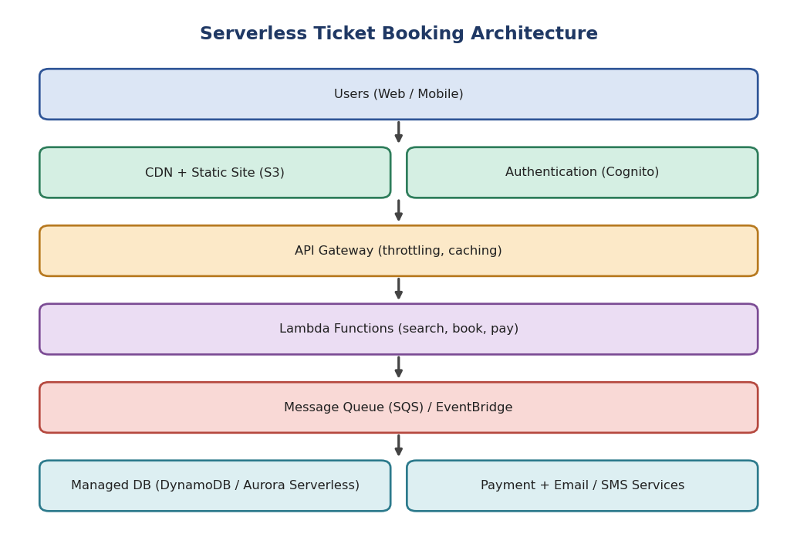
Figure 8: Serverless ticket booking architecture
Component | Service Example | Function
Frontend | S3 + CloudFront (static site / SPA) | Fast, globally cached UI
Authentication | Cognito / Auth0 | Sign-up, login, tokens
API layer | API Gateway | Routing, throttling, caching, authorisation
Compute | AWS Lambda / Azure Functions | Search events, hold seats, process booking
Queue | SQS / EventBridge / SNS | Buffer bookings, decouple payment and notifications
Database | DynamoDB / Aurora Serverless | Seat inventory and bookings
Integrations | Payment gateway, SES / SNS for tickets and SMS | Payments and confirmations

2. Event-Driven Computing and Scalability
- Events trigger functions: An HTTP request, queue message, database change (stream) or schedule invokes a function. No server runs idle.
- Automatic scaling: The platform runs as many function instances in parallel as there are events, from zero to thousands, with no capacity planning.
- Decoupling: Booking request -> queue -> payment function -> email function. Each stage scales independently and failures are retried.
- Spike handling: When a popular event is announced, concurrency increases within seconds; a queue absorbs bursts.
- Cost model: Pay per request and per millisecond of execution, so there is no cost between spikes.

3. Role of Managed Databases, API Gateway and Message Queues
Service | Role | Benefit for ticketing
Managed database | Auto-scaling storage and throughput, multi-AZ, backups handled by provider; conditional writes prevent double booking | No DB administration; consistent seat inventory
API Gateway | Single entry point: authentication, rate limiting, request validation, response caching, versioning | Protects backend from floods; reduces calls
Message queue | Buffers bookings, enables retries and dead-letter queues | Smooths spikes; no lost orders
Cache (optional) | DAX / Redis for event listings | Faster reads during popular events

4. Advantages and Limitations of Serverless
Advantages | Limitations
Auto-scales instantly to spikes | Cold-start latency (mitigate with provisioned concurrency)
No server management or patching | Execution time and memory limits per function
Pay-per-use; cheap for bursty workloads | Cost can exceed containers for sustained high load
Built-in high availability | Vendor lock-in; harder local testing and debugging
Faster development and deployment | Database connection limits and concurrency throttles; need careful design

Evaluation: Serverless is well suited to this spiky workload. Use provisioned concurrency for the booking path, queues for burst control, and conditional database writes to maintain seat consistency.

Set 2 - Question 4: Cloud ETL/ELT Pipeline for a Multinational
Scenario: A multinational gathers data from sales, finance, manufacturing and customer support and requires a centralized, high-quality analytics platform.

1. ETL/ELT Pipeline Design
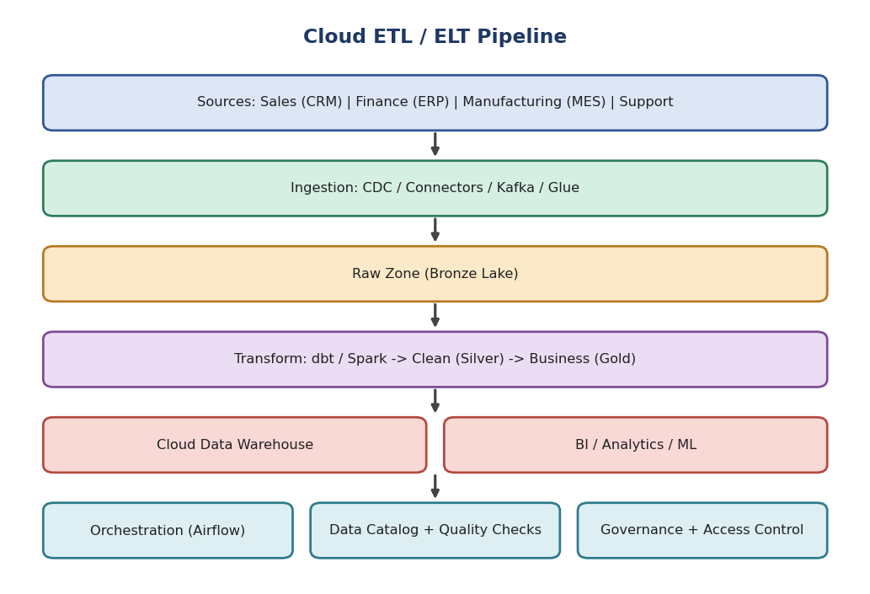
Figure 9: Cloud ETL/ELT pipeline with medallion layers
Stage | Description | Tools
Extract | Connectors and change data capture from CRM, ERP, MES, ticketing; files and APIs | Fivetran, Debezium, Glue, Data Factory
Load (raw) | Land data unchanged in the lake (bronze) with timestamps | S3 / ADLS / GCS
Transform | Clean, deduplicate, standardise currencies and units, join across domains (silver, gold) | dbt, Spark, SQL in warehouse
Serve | Star schema in cloud warehouse for reporting | Snowflake, BigQuery, Redshift

ETL vs ELT: ETL transforms before loading and suits strict, sensitive data. ELT loads first and transforms inside the scalable warehouse; it is preferred in cloud because compute is elastic and raw data is retained for reprocessing. A hybrid approach is common.

2. Data Quality, Metadata Management and Governance
Area | Practice
Data quality | Validation rules (nulls, ranges, duplicates, referential integrity) using Great Expectations / dbt tests; quarantine bad records; quality scorecards
Master data | Common definitions and master data for customer, product, currency
Metadata management | Data catalog (Glue Catalog, Purview, Alation) with business glossary, schema registry, technical metadata
Lineage | Track data from source to dashboard for impact analysis and audit
Governance | Data owners and stewards, classification, role-based access, column masking, GDPR retention rules
Security | Encryption, audit logging, regional data residency

3. Workflow Orchestration and Scheduling
- Orchestrators: Apache Airflow (MWAA / Cloud Composer), Azure Data Factory, Step Functions, Prefect, Dagster.
- Roles: Define dependencies as DAGs (extract -> validate -> transform -> load -> publish), schedule by time or event, retry on failure, send alerts, backfill historical runs.
- Benefits: Visibility, reliability, parameterised and version-controlled pipelines, SLAs for report freshness.

4. Optimizing Query Performance and Storage Costs
Goal | Technique
Faster queries | Partitioning and clustering, columnar formats (Parquet), materialised views, aggregate tables, result caching
Efficient modelling | Star schema, avoid SELECT *, incremental models
Compute control | Auto-suspend / auto-scale warehouses, workload isolation, query limits
Lower storage cost | Compression, lifecycle tiering of raw data, delete temporary tables
Cost governance | Budgets, usage monitoring, chargeback by department

Set 2 - Question 5: ML Platform for Predicting Delivery Delays
Scenario: A logistics company predicts delivery delays using shipment history, weather and live GPS, needing continuous training and real-time predictions.

1. Cloud ML and Analytics Architecture
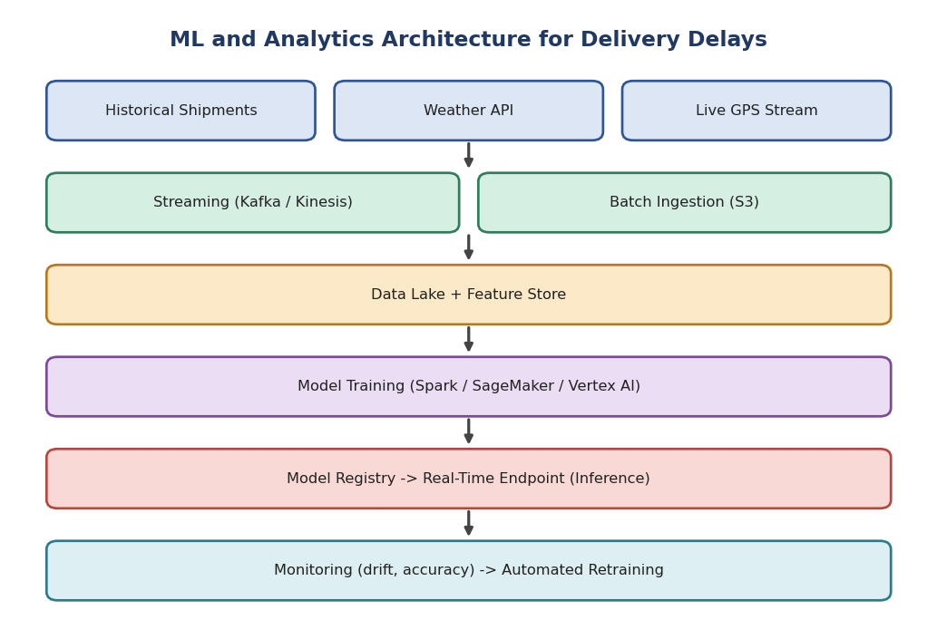
Figure 10: End-to-end ML architecture with continuous training
Layer | Component | Purpose
Ingestion | Kafka / Kinesis for GPS; API pollers for weather; batch loads of shipment history | Unified data flow
Storage | Data lake (S3) + feature store (SageMaker FS / Feast) | Raw data and reusable features for training and serving
Processing | Spark / Flink for joins and aggregations | Large-scale feature computation
Training | SageMaker / Vertex AI / Azure ML on GPU or distributed clusters | Build models (XGBoost, LSTM)
Deployment | Model registry and real-time endpoint; batch scoring for planning | Predictions for dispatchers and customers
Monitoring | Drift, accuracy, latency dashboards | Maintain quality

2. Big Data Technologies for Training and Inference
- Training: Spark MLlib and distributed frameworks process billions of historic records in parallel; hyperparameter tuning runs in parallel on clusters.
- Inference (real time): Streaming job reads GPS events, joins weather and shipment features from the feature store, and calls the model endpoint to produce delay probability in under a second.
- Inference (batch): Nightly scoring of all planned routes.
- Storage formats: Parquet/Delta for efficient scans; Redis/DynamoDB online store for millisecond feature lookup.

3. Cloud-Native AI/ML Services for Deployment and Monitoring
Capability | Service example | Details
Managed training | SageMaker Training, Vertex AI | Spot training, distributed jobs, experiment tracking
Model registry and versioning | SageMaker Model Registry, MLflow | Approval workflow, reproducibility
Deployment | Managed endpoints with autoscaling, blue/green and canary | Safe rollout and rollback
Monitoring | Model Monitor / Vertex Model Monitoring | Data drift, concept drift, bias, prediction quality
Pipelines (MLOps) | SageMaker Pipelines, Kubeflow, Azure ML Pipelines | Automated train-evaluate-deploy
Explainability | SHAP-based tools | Why a shipment is predicted late

4. Ingestion, Feature Engineering and Model Updates
Area | Strategy
Large-scale ingestion | Partitioned streams, schema registry, back-pressure handling, replayable logs, autoscaling consumers
Feature engineering | Time-window features (average speed last 15 min), distance to destination, weather severity, traffic, day/hour, historical route delay; same code for training and serving to avoid skew
Feature store | Offline store for training, online store for inference; point-in-time correctness
Continuous training | Scheduled (daily) and trigger-based retraining when drift is detected; automated evaluation against champion model
Safe model updates | Shadow deployment, canary release, A/B tests, automatic rollback
Data quality | Validation on incoming data; handle missing GPS points and outliers

Set 3 - Question 1: Legacy Application Migration to the Cloud
Scenario: A manufacturer migrates legacy enterprise applications and databases from an on-premises data center, minimizing downtime while ensuring performance and security.

1. Cloud Migration Strategy
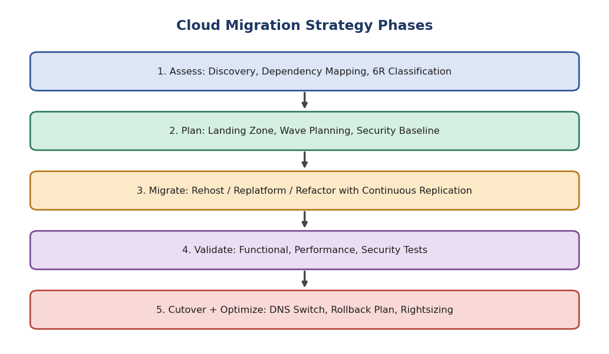
Figure 11: Phased cloud migration strategy
Phase | Key activities
Assess | Inventory servers, applications, databases; map dependencies; measure baseline performance; evaluate licensing and compliance
Plan | Set up landing zone (accounts, network, IAM, logging); group applications into waves (low-risk first); define success criteria, rollback plan, communication
Migrate | Replicate data continuously; migrate wave by wave using the suitable 6R approach
Validate | Functional, performance, security and user acceptance tests
Cutover and optimize | Switch traffic during a maintenance window, keep rollback ready, then right-size and decommission old systems

2. Applying the Six Migration Approaches (6 Rs)
Approach | Meaning | Manufacturing example | Downtime / effort
Rehost (lift and shift) | Move as-is to VMs | Legacy ERP application server moved to cloud VMs | Low effort, short downtime
Replatform (lift, tinker and shift) | Small optimisations without changing the core | Move on-premises Oracle/SQL Server to managed RDS; app server to managed platform | Medium
Refactor / Re-architect | Redesign to cloud-native | Break MES monolith into microservices/containers with serverless components | High effort; best long-term
Repurchase | Replace with SaaS | Replace custom CRM or HR system with Salesforce / Workday | Medium; data migration and training
Retire | Switch off unused applications | Old reporting tools with no users | Saves cost
Retain | Keep on-premises for now | Shop-floor control system needing ultra-low latency or with regulatory restrictions | None; revisit later

3. Validating Performance After Migration
- Baseline comparison: Compare response time, throughput, CPU, memory, IOPS and error rate against pre-migration baselines.
- Load and stress testing: Tools such as JMeter / k6 simulate peak production load.
- Functional and integration testing: Verify interfaces with other systems, batch jobs and reports.
- Data validation: Row counts, checksums and sample reconciliation between source and target databases.
- Monitoring: CloudWatch / Azure Monitor / APM dashboards for 2-4 weeks, with alerts for deviations.
- Security validation: Vulnerability scans, IAM and network rule review, penetration testing.
- User acceptance: Business users sign off on critical workflows.

4. Reducing Migration Risks and Downtime
Risk | Strategy
Extended downtime | Continuous replication (AWS DMS, Azure Migrate, CDC), then short cutover; migrate in off-peak windows
Failed migration | Pilot migration first; detailed rollback plan; keep source system until stable
Performance degradation | Right-size using assessment data; use auto-scaling and caching; test before cutover
Data loss or corruption | Backups before cutover; validation checksums
Security gaps | Landing zone with guardrails, encryption, least-privilege IAM from day one
Dependency surprises | Dependency mapping; move dependent applications in the same wave
Cost overrun | TCO estimate, tagging, budgets, rightsizing after migration
User impact | Training, communication, phased rollout, hypercare support

Set 3 - Question 2: Smart City IoT Data Platform
Scenario: A smart city deploys thousands of IoT sensors (traffic, air quality, energy, public safety) whose data must be processed in real time for decision-making.

1. Cloud Architecture for IoT Data Collection and Analytics
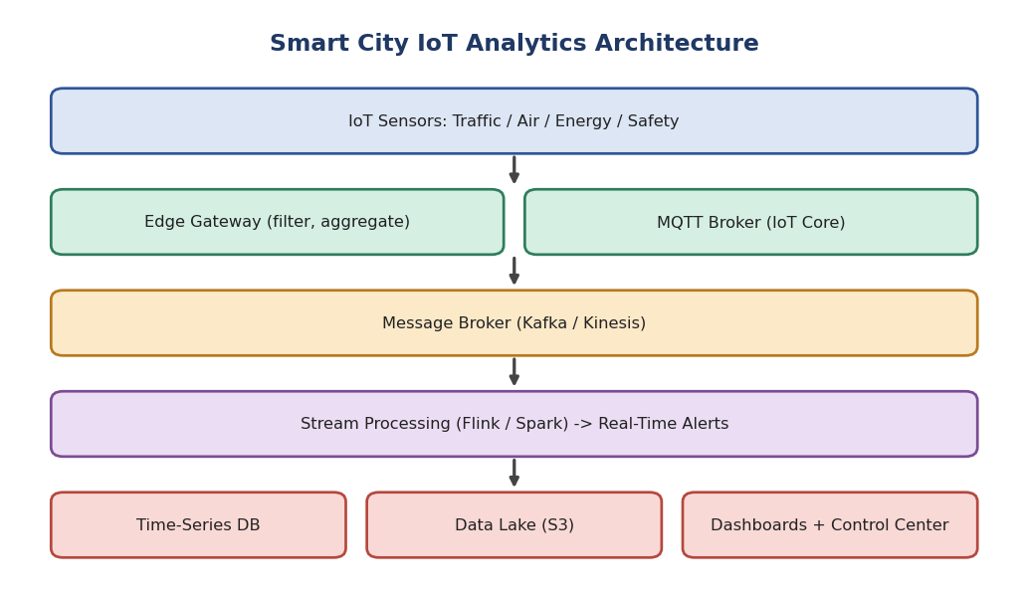
Figure 12: Smart city IoT analytics architecture
Layer | Component | Role
Device | Sensors, cameras, meters with secure firmware | Generate readings
Edge / gateway | Local gateway for filtering, aggregation, protocol translation (LoRaWAN, Zigbee to MQTT) | Reduces bandwidth and latency
Ingestion | MQTT broker / AWS IoT Core / Azure IoT Hub | Secure device connectivity at scale
Messaging | Kafka / Kinesis / Event Hubs | Durable, scalable event backbone
Processing | Flink / Spark Streaming / Stream Analytics | Real-time aggregation and rules
Storage | Time-series DB (InfluxDB / Timestream), data lake (S3), warehouse | Hot, warm and cold data
Presentation | Dashboards, alerts, APIs for city control center | Decisions

2. Integrating Message Brokers, Stream Processing and Cloud Storage
- Sensors publish readings to MQTT topics (e.g., city/traffic/zone5). The IoT hub authenticates devices and forwards messages to the central broker (Kafka/Kinesis).
- The stream processor consumes from the broker, cleans data, computes windowed aggregates (average PM2.5 per 5 minutes) and detects events (traffic congestion, gas leak, outage).
- Results go to three destinations: (1) alerts and dashboards in real time, (2) time-series database for recent queries, (3) data lake for long-term history and machine learning.
- The broker acts as a buffer so storage and processing can scale and fail independently.

3. Handling High-Volume, High-Velocity Sensor Data
Technique | Description
Edge processing | Filter noise, send only changes or aggregates
Partitioning | Partition topics by sensor ID / zone for parallelism
Batching and compression | Group messages and use Avro / Protobuf for compactness
Windowing and sampling | Tumbling / sliding windows; downsample old data
Back-pressure and buffering | Broker retention absorbs bursts
Tiered storage | Hot (days) in time-series DB, warm in Parquet, cold in archive
Idempotent processing | Handles duplicates and late events with watermarks

4. Scalability, Reliability and Security
Aspect | Techniques
Scalability | Auto-scaling consumers, partitioned streams, serverless processing, horizontal scale of storage
Reliability | Multi-AZ brokers with replication factor 3, checkpointing, dead-letter queues, device reconnect and buffering at gateway, monitoring
Device security | X.509 certificates per device, secure boot, signed OTA updates, device registry and revocation
Data security | TLS for MQTT, encryption at rest, network segmentation, IAM, API authentication
Privacy | Anonymisation of camera and location data, retention limits, access audit

Set 3 - Question 3: Business Intelligence for a Global E-Commerce Company
Scenario: Executives need interactive dashboards for sales performance, customer behaviour and regional trends with real-time analytics and historical reporting.

1. Cloud BI Architecture
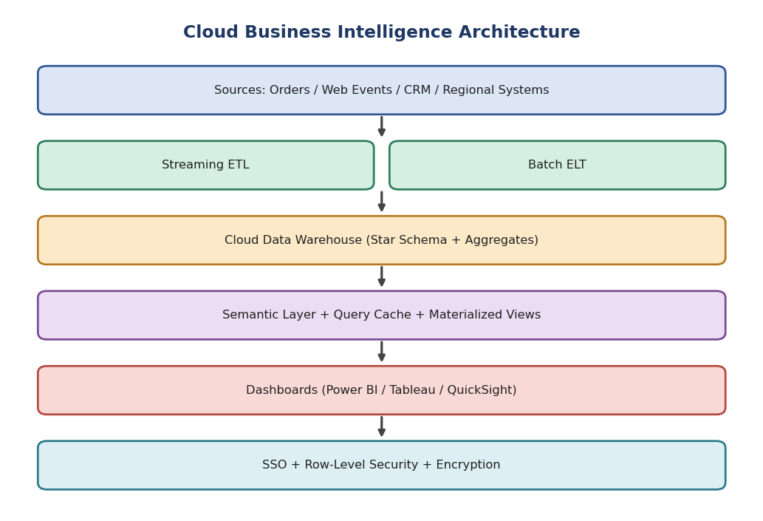
Figure 13: Cloud business intelligence architecture
Layer | Design | Purpose
Sources | Order system, web/app clickstream, CRM, payments, regional ERPs | Business data
Ingestion | Streaming (Kafka/Kinesis -> warehouse) for real-time; scheduled ELT for history | Both real-time and historical views
Warehouse | Snowflake / BigQuery / Redshift with star schema (fact_sales, dim_customer, dim_product, dim_region, dim_date) | Single source of truth
Semantic layer | Governed metrics (revenue, conversion, AOV) in LookML / Power BI model | Consistent definitions
Visualization | Power BI / Tableau / Looker / QuickSight | Interactive dashboards
Security | SSO, RLS, encryption, audit | Protect reports

2. Integrating Visualization Tools with Cloud Data Warehouses
- Connection modes: Live/DirectQuery sends queries to the warehouse for real-time data; Import/Extract caches data in the BI engine for speed. A composite model uses live for current-day sales and import for history.
- Connectivity: Native connectors via JDBC/ODBC or REST; credentials managed through service principals and OAuth/SSO.
- Semantic model: BI tool reads relationships and measures defined once, so every dashboard shows identical numbers.
- Embedding: Dashboards can be embedded in executive portals or mobile apps.

3. Optimizing Dashboard Performance with Large Datasets
Technique | Effect
Pre-aggregated tables and materialized views (daily/regional summaries) | Dashboards query small tables instead of billions of rows
Partitioning and clustering by date and region | Scans less data
Result caching and BI extracts (Hyper / VertiPaq / SPICE) | Sub-second repeat queries
Incremental refresh | Refresh only new data
Fewer visuals per page, default filters, drill-through instead of detail on first load | Faster rendering
Query optimisation: select only required columns, avoid complex row-level calculations | Lower compute
Warehouse auto-scaling and workload isolation for BI | Stable response under concurrency

4. Security Measures for Reports and Sensitive Data
Measure | Implementation
Authentication | SSO with MFA through corporate identity provider
Authorization | Role-based access to workspaces; row-level security (regional managers see only their region); column-level security / masking for PII
Encryption | TLS in transit; AES-256 at rest; customer-managed keys
Data governance | Sensitivity labels, DLP, restrict export/download and sharing
Auditing | Log report access and queries; alerts for unusual activity
Network | Private endpoints, IP restrictions, VPN
Compliance | GDPR / CCPA handling, retention policy

Set 3 - Question 4: Online Gaming Performance Monitoring and Optimization
Scenario: An online gaming company has fluctuating workloads; at peak hours users report high latency and reduced performance.

1. Cloud Monitoring and Performance Optimization Solution
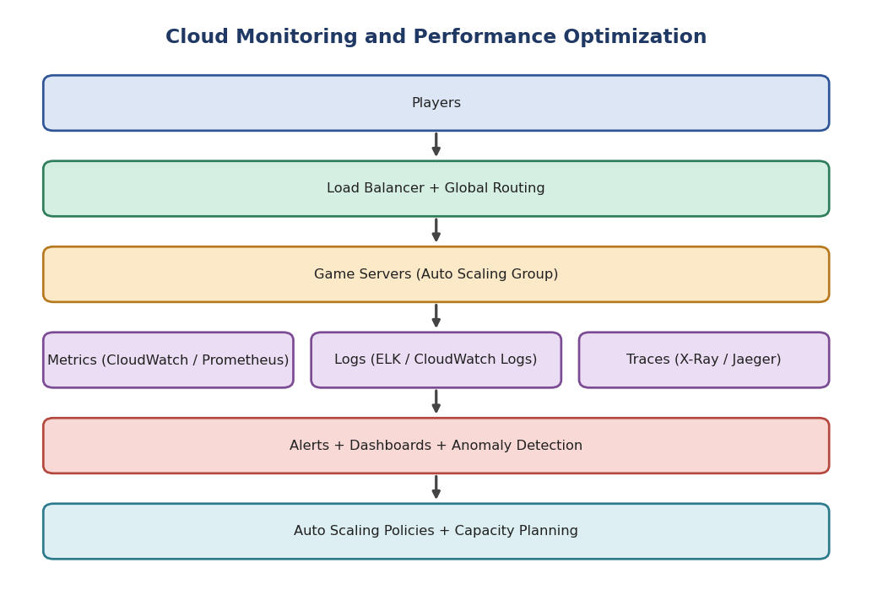
Figure 14: Observability and auto-scaling feedback loop for gaming
Component | Solution | Purpose
Compute | Game servers in auto scaling groups or Kubernetes with game-server fleets (Agones / GameLift) in regions close to players | Capacity follows demand
Traffic | Load balancer, global accelerator, UDP/TCP optimized routing | Low latency path
Observability | Metrics + Logs + Traces, dashboards, alerts | Find bottlenecks
Feedback | Alerts and metrics drive scaling policies and capacity reviews | Closed-loop optimization

2. How Metrics, Logs and Tracing Identify Bottlenecks
Pillar | Examples for gaming | What it reveals
Metrics | CPU, memory, network I/O, concurrent players, tick rate, p95/p99 latency, packet loss, DB query time, queue depth | WHAT is wrong and WHEN (e.g., CPU 95% at 8 pm)
Logs | Server errors, matchmaking failures, slow DB queries, connection timeouts | WHY it happened (error details)
Distributed tracing | Request path: client -> gateway -> matchmaking -> game server -> database | WHERE the delay is (e.g., 400 ms in inventory service)
Synthetic / RUM | Ping tests from regions; real-user monitoring | Regional latency problems

Diagnosis flow: Alert on high p99 latency -> check metrics to locate the saturated resource -> use traces to find the slow service -> read logs for the root cause -> fix (scale, cache, query tuning).

3. Resource Optimization and Capacity Planning
Strategy | Details
Auto-scaling policies | Target-tracking on concurrent players or CPU; scheduled scaling before daily peaks and events; predictive scaling from historical patterns
Right-sizing | Choose instance types matched to CPU/network need; use compute-optimized or GPU where needed
Caching | Redis for leaderboards and sessions; CDN for patches and assets
Database tuning | Read replicas, indexing, sharding by player ID, connection pooling
Capacity planning | Analyse trends and growth; load test for upcoming launches; plan headroom (e.g., 30%)
Regional placement | Add game servers in regions with high player counts

4. Improving Availability while Controlling Cost
Goal | Method
Availability | Multi-AZ deployment, health checks, automatic replacement, rolling updates, multi-region for popular games
Cost control | Reserved capacity for baseline; Spot instances for non-critical workloads (e.g., bots, batch analytics); scale-in at off-peak
Storage / data cost | Move old logs to cheaper tiers; set log retention
Visibility | Cost dashboards, budgets, tagging per game or region
Resilience testing | Chaos tests and failover drills

Set 3 - Question 5: Data Lifecycle Management for a Financial Institution
Scenario: A financial institution stores petabytes of transaction data for regulatory compliance and analytics and must retain history while managing storage cost.

1. Cloud-Based Data Lifecycle Management Strategy
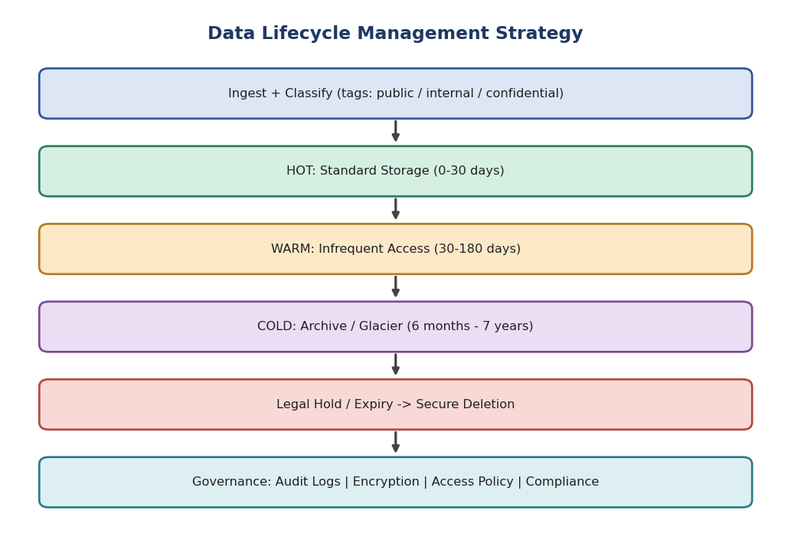
Figure 15: Data lifecycle tiers and governance
Tier | Age / usage | Storage class | Relative cost | Retrieval
Hot | 0-30 days; active analytics, fraud detection | Standard / SSD | Highest | Milliseconds
Warm | 30-180 days; periodic reporting | Infrequent Access | About 40% lower | Milliseconds, retrieval fee
Cold | 6 months-2 years; audits | Archive (Glacier Instant / Flexible) | About 80% lower | Minutes to hours
Deep archive | 2-7+ years; regulatory retention only | Glacier Deep Archive | About 95% lower | 12 hours
Expired | After retention period | Secure deletion | None | N/A

2. Data Classification, Retention Policies and Archival Storage
Step | Implementation
Data classification | Tag data as public, internal, confidential or restricted (PII, card data) using automated discovery (Macie / Purview); classification drives encryption, access and retention
Retention policies | Map regulations (e.g., 5-7 years for transaction records under financial regulations, AML rules) to data types; policy per data class
Lifecycle rules | Automated transition rules: Standard -> IA after 30 days -> Archive after 180 days -> Deep Archive after 2 years -> delete after retention
Archival storage | Immutable WORM (Object Lock) for compliance records; encrypted; stored in multiple AZs or regions
Legal hold | Suspend deletion for data under investigation or litigation
Secure deletion | Crypto-shredding (delete keys) and verified deletion with certificates
Metadata catalog | Index archived data so it can be found and restored when needed

3. Governance, Auditing and Regulatory Compliance
- Importance: Financial regulators (SOX, PCI-DSS, GDPR, Basel, RBI guidelines) require accurate, tamper-proof records, data privacy and proof of control. Failure leads to fines, legal exposure and loss of trust.
- Governance: Defined data owners and stewards, policies, data catalog and lineage, quality rules, approval workflows.
- Auditing: Immutable logs (CloudTrail) of every access, modification and deletion; periodic internal and external audits; reports to regulators.
- Compliance in big data: Data residency controls, masking and tokenization of sensitive fields, right-to-erasure handling where legally permitted, regular compliance scans (Config, Security Hub, Azure Policy).
- Separation of duties: Those who manage storage cannot alter audit logs.

4. Balancing Accessibility, Security and Cost
Objective | Technique | Trade-off managed
Accessibility | Data catalog, query-in-place over archives (Athena / Synapse), restore on demand, intelligent tiering for unpredictable access | Fast enough for audits without keeping everything hot
Security | Encryption with KMS, least-privilege IAM, MFA, private endpoints, immutability | Strong protection without blocking authorised use
Cost | Lifecycle automation, compression, columnar formats (Parquet), deduplication, delete expired data, monitor storage analytics | Up to 70-90% savings on old data
Resilience | Cross-region replication of critical archives; periodic restore tests | Durability vs. replication cost

Conclusion: Classify data, apply automated lifecycle policies, archive immutably, and govern with audit logging so the institution stays compliant, secure and cost-efficient.

